--------------------------------------------------- TALENT DETAILS ------------------------------------------------------

Talent Name: | Max Poole
Email: | max.poole@worthing.ac.uk | Phone number: | 07358 452965
Agent/manager: | Sarah Croft | Phone number: | 07753 286359

----------------------------------------------- PRODUCTION DETAILS -------------------------------------------------

Producers Name: | Harrison Cable
Production Company: | Suntory
Production Title: | Lucozade Energy | Phone number: | 01903 258316

-------------------------------------------------------- PAYMENT -----------------------------------------------------------

Compensation: | £100 (1 day)

Talent authorizes, as part of Production and for the compensation stated above, Producer to:
1. Photograph Talent and record his/her voice and likeness for the purpose of Production, whether by film, videotape, magnetic tape, digitally or otherwise;
2. Make copies of the photographs and recordings so made;
3. Use Talent’s name and likeness for the purposes of education, promotion or advertising of the sale or trading in the photographs, recordings and any copies so made.
Talent understands the master tape remains the property of the Producer and, unless otherwise stated, that there will be no restrictions on the number of times that Talent’s name and likeness may be used. Also, unless otherwise stated, there will be no restrictions to the geographical distribution of Production.
Talent understands the terms described in this contract. He/she is over 18 years of age and has the authority to sign this contract and grant Producer the rights given under this contract.
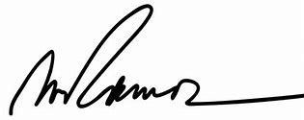
If Talent is a minor under the laws of the state where his/her appearance is recorded:
Rebecca Poole
06/02/2020
_________________________________ _____________________________ _________________
Legal Guardian Signature Date
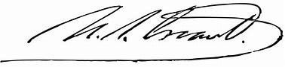
07/02/2020
_________________________________ _________________
Talent Signature Date

